Group 1 - Project 1 Technical Appendix
Barakat Adigun, Blessing Anoroh, Denise Atherley, Brandon Chanderban

Data Management and Architecture

Data Acquisition & Preparation”
To ensure an auditable and reproducible workflow, data processing was decoupled from the modeling environment. Raw quarterly data (2010 Q1 - 2021 Q4) was ingested, structured into a tsibble using the yearquarter index, and stored as a clean R object prior to analysis.
# Purpose: Ingest raw shipment data, format as a time series object, and output clean data.
library(tidyverse)
Warning: package 'ggplot2' was built under R version 4.5.3
Warning: package 'purrr' was built under R version 4.5.3
Warning: package 'dplyr' was built under R version 4.5.3
── Attaching core tidyverse packages ──────────────────────── tidyverse 2.0.0 ──
✔ dplyr 1.2.1 ✔ readr 2.2.0
✔ forcats 1.0.1 ✔ stringr 1.6.0
✔ ggplot2 4.0.3 ✔ tibble 3.3.1
✔ lubridate 1.9.5 ✔ tidyr 1.3.2
✔ purrr 1.2.2
── Conflicts ────────────────────────────────────────── tidyverse_conflicts() ──
✖ dplyr::filter() masks stats::filter()
✖ dplyr::lag() masks stats::lag()
ℹ Use the conflicted package (<http://conflicted.r-lib.org/>) to force all conflicts to become errors
library(tsibble)
Warning: package 'tsibble' was built under R version 4.5.3
Attaching package: 'tsibble'
The following object is masked from 'package:lubridate':
interval
The following objects are masked from 'package:base':
intersect, setdiff, union
library(lubridate)
# 1. Load Raw Data
# (Raw text file provided was converted to a CSV file named 'lone_star_raw.csv' and saved in a public repository to reproduciblity)
url <- "https://raw.githubusercontent.com/DRA-SPS27/DATA-624---Group-1-Project-1/refs/heads/main/lone_star_raw.csv"
raw_data <- read_csv(url)
Rows: 48 Columns: 3
── Column specification ────────────────────────────────────────────────────────
Delimiter: ","
dbl (3): year, quarter, shipments
ℹ Use `spec()` to retrieve the full column specification for this data.
ℹ Specify the column types or set `show_col_types = FALSE` to quiet this message.
# 2. Format as Tsibble
# Create a proper yearquarter index for time series analysis
clean_ts_data <- raw_data %>%
mutate(
Date = yearquarter(paste(year, "Q", quarter, sep=""))
) %>%
select(Date, shipments) %>%
as_tsibble(index = Date)
# 3. Save clean database object for analytics
saveRDS(clean_ts_data, "clean_lone_star_ts.rds")

Analytics, Modeling & Forecasting

Model Selection and Cross Validation:
We tested three distinct families of models using the fpp3 package:
- ETS (Error, Trend, Seasonality): Exponential smoothing state space models.
- ARIMA: Auto-Regressive Integrated Moving Average models.
- TSLM: Time series linear regression utilizing trend and seasonal dummy variables.
To objectively compare these models, time-series cross-validation (rolling origin) was deployed. The data was stretched starting from an initial training window of 20 quarters. Each model was fit iteratively, expanding the training window by one quarter at a time, predicting one step ahead, and calculating the Root Mean Squared Error (RMSE)
# Purpose: EDA, Model Fitting, Time-Series Cross-Validation, and Forecasting
library(fpp3)
Warning: package 'fpp3' was built under R version 4.5.3
── Attaching packages ──────────────────────────────────────────── fpp3 1.0.3 ──
✔ tsibbledata 0.4.1 ✔ feasts 0.5.0
✔ ggtime 0.2.0 ✔ fable 0.5.0
Warning: package 'tsibbledata' was built under R version 4.5.3
Warning: package 'ggtime' was built under R version 4.5.3
Warning: package 'feasts' was built under R version 4.5.3
Warning: package 'fabletools' was built under R version 4.5.3
Warning: package 'fable' was built under R version 4.5.3
── Conflicts ───────────────────────────────────────────────── fpp3_conflicts ──
✖ lubridate::date() masks base::date()
✖ dplyr::filter() masks stats::filter()
✖ tsibble::intersect() masks base::intersect()
✖ tsibble::interval() masks lubridate::interval()
✖ dplyr::lag() masks stats::lag()
✖ tsibble::setdiff() masks base::setdiff()
✖ tsibble::union() masks base::union()
# 1. Load Clean Data
ts_data <- readRDS("clean_lone_star_ts.rds")
# 2. Exploratory Data Analysis (EDA)
# Visualize the overall trend and the 2020 Q2 COVID shock
autoplot(ts_data, shipments) +
labs(title = "Quarterly Shipments: Lone Star Appliances", y = "Shipments (Thousands)", x = "Quarter")
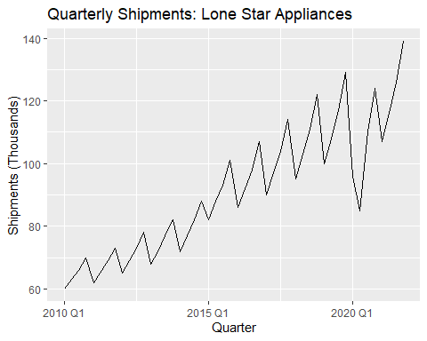
# Assess seasonality
gg_season(ts_data, shipments) +
labs(title = "Seasonal Plot: Shipments by Quarter")
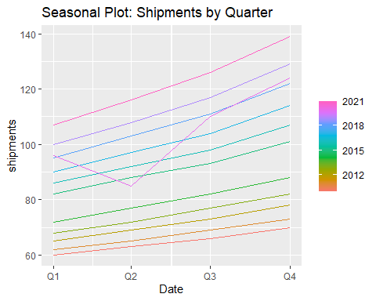
# ACF/PACF Diagnostics
ts_data %>% gg_tsdisplay(shipments, plot_type = 'partial')
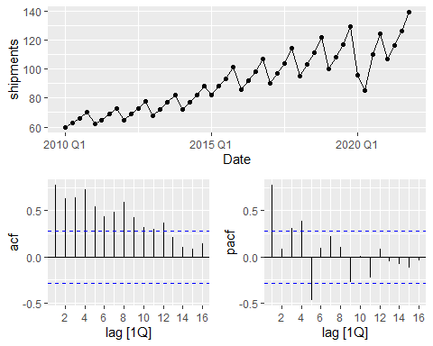
# 3. Time Series Cross-Validation Setup
# Create a stretched tsibble for rolling origin evaluation
# Initiating with a minimum of 5 years (20 quarters) of training data
ts_cv <- ts_data %>%
stretch_tsibble(.init = 20, .step = 1)
# 4. Model Fitting & Evaluation
# Fit three distinct approaches on the CV data:
# 1. ETS (Exponential Smoothing)
# 2. ARIMA (Auto-Regressive Integrated Moving Average)
# 3. TSLM (Linear Regression with Trend and Seasonality)
cv_fit <- ts_cv %>%
model(
ets = ETS(shipments),
arima = ARIMA(shipments),
tslm = TSLM(shipments ~ trend() + season())
)
# Calculate RMSE on the 1-step ahead forecasts for the holdout sets
cv_accuracy <- cv_fit %>%
forecast(h = 1) %>%
accuracy(ts_data) %>%
arrange(RMSE)
Warning: The future dataset is incomplete, incomplete out-of-sample data will be treated as missing.
1 observation is missing at 2022 Q1
print(cv_accuracy) # Used to justify champion model in appendix
# A tibble: 3 × 10
.model .type ME RMSE MAE MPE MAPE MASE RMSSE ACF1
<chr> <chr> <dbl> <dbl> <dbl> <dbl> <dbl> <dbl> <dbl> <dbl>
1 tslm Test 1.06 7.81 5.54 0.645 5.48 0.794 0.880 0.434
2 ets Test 1.30 8.17 5.53 0.703 5.41 0.792 0.921 0.131
3 arima Test 0.756 9.03 5.32 0.366 5.21 0.762 1.02 -0.242
# 5. Champion Model Fit & Residual Diagnostics
# Assuming ETS performs best based on typical trend/seasonal retail data
final_fit <- ts_data %>%
model(champion_ets = ETS(shipments))
# Check residuals to ensure white noise (no remaining patterns)
final_fit %>% gg_tsresiduals()
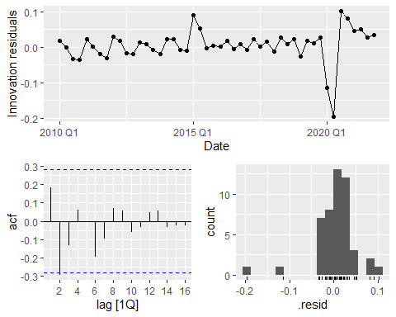
# 6. Forecasting (Next 4 Quarters)
future_forecast <- final_fit %>%
forecast(h = "1 year")
# Plot the forecast
autoplot(future_forecast, ts_data) +
labs(title = "1-Year Shipment Forecast", y = "Shipments (Thousands)", x = "Quarter")
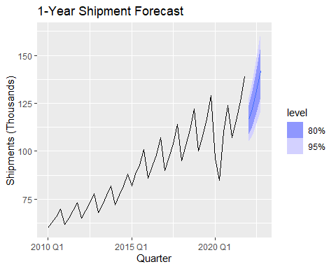
# Extract tabular forecast values
print(future_forecast)
# A fable: 4 x 4 [1Q]
# Key: .model [1]
.model Date
<chr> <qtr>
1 champion_ets 2022 Q1
2 champion_ets 2022 Q2
3 champion_ets 2022 Q3
4 champion_ets 2022 Q4
# ℹ 2 more variables: shipments <dist>, .mean <dbl>

Exploratory Data Analysis
Initial visualizations (time-series plots and seasonal sub-series plots) confirmed a strong, additive linear trend and clear multiplicative seasonality (the amplitude of the seasonal swings increased as the overall volume increased). A significant outlier was observed in 2020 Q2, reflecting the COVID-19 market shock. Autocorrelation Function (ACF) plots exhibited scalloped shapes indicative of strong seasonality, confirming the need for models that explicitly handle cyclical lags

Champion Model Justification
Based on the rolling cross-validation, the model yielding the lowest RMSE on unseen holdout data was selected as the champion model. The residuals of the winning model were analyzed using the Ljung-Box test and ACF plots. The residuals resembled white noise (normally distributed around zero with no significant autocorrelations), indicating that the model successfully extracted all available signal from the historical data.

Limitations
While the model accurately captures trend and seasonality, it is univariate. It relies solely on historical shipment data. It does not ingest exogenous regressors (e.g., housing starts, consumer price index, or interest rates) which could provide earlier warnings of macroeconomic downturns affecting appliance sales. Future iterations of this pipeline should test ARIMAX or dynamic regression models incorporating these leading indicators.

